**Article –Newsday**

Disadvantages of electric vehicles

* The batteries in the electric vehicles are rare:
  + 
  + Use a lot of lithium, the lightest metal in the world and the lightest solid element under normal conditions
  + This results in making electric cars hard to mass produce in Europe because of insufficient access to a source of lithium
  + Wrong disposal of lithium batteries can also be dangerous as they are an electrical hazard and very flammable
* Producing an electric car itself creates more emissions and greenhouse gases
  + The raw materials for a car have to be mined: mining creates a lot of greenhouse gases (4-7 per cent of greenhouse gas emissions globally).
  + Making a petrol or diesel car releases about 7-10 tonnes of CO2 but an electric car is that plus the battery
    - 150kg of CO2 is released for every 1 kilowatt hour (kWh) of battery capacity. And considering that an electric car has a battery of a minimum capacity of 60kWh. That is a further 9 tonnes of CO2. So at this point an electric car is almost 2-2.5x worse for the environment which completely defeats the purpose of buying an electric which is to reduce CO2 emissions and greenhouse gases
* There aren’t enough charging points considering that it takes at least a dedicated 30mins and not a couple of mins when it comes to petrol or diesel
  + 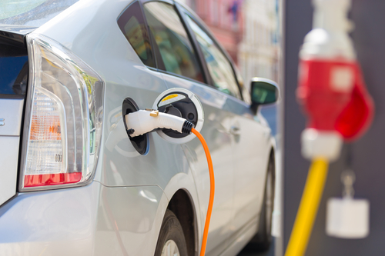
  + You might think that this will not be a huge issue if everyone just installs a charging point by their house but that’s not really an option for people living in streets of terraced housing where on-street parking means they often have to park their cars some distance from their house.
* EVs are a lot more expensive than fossil fuelled vehicles
  + The average transaction price for an electric vehicle (EV) is $56,437, according to Kelley Blue Book — roughly $10,000 higher than the overall industry average of $46,329 so most of the people willing to make a change and buy an EV cannot even afford it
  + An EV is equivalent to an entry-level luxury car.

*What if everyone plugs their car into a charger when they arrive at work at 9am, or when they get home at 6pm? How will the surge in demand be dealt with?*